SLW Home Improvements Greenville, NC
Group 1 MIS 4173
Carson Hatem – Systems Analyst
Austin Bing-Zaremba – Business Analyst
Christian Lancaster – Co-Product Owner
Jackson Ingalls Database/Programming Coordinator
2/10/25

Project Description and Analysis 1
Executive Summary 2
Narrative and Conclusions 2
Company Background & Current Environment 2
Problem Analysis 2
Proposed System Objectives and Constraints 3
Objectives: 3
Constraints: 3
Expected Benefits 3
Context Diagram 3
Use Case Diagram 4
Sprint 2 5
Non-Functional Requirements 5
Sprint 3 7
Executive Summary 7
Entity Relationship Diagram 7
DFD Level 0 8
DFD Level 1 9
Hardware and Software Requirements 11
Program Plan 11
Sprint 4 11
Executive Summary 12
Customer Interactions with the Site 12
Services 13
Request Quote 14
About us 15
Contact Us 15
Admin Login 16
Admin Panel 19
Manage Services 20
Customer Quotes 21
Edit Customer Quotes 21
Logging Out 24
System Overview 25
Restart and Troubleshooting 25
System Requirements 25
Admin Login 25
Backing Up Data 27
Software Maintenance 27
Database Recovery 28
Current Limitations 28
Updated Hardware and Software Requirements 29
Software Requirements 29
Business Readiness 30
Technical Readiness 30
People Readiness 31
Lessons Learned 31
Challenges, Problems, and Discoveries 31

Project Description and Analysis

Executive Summary
SLW Home Improvements is a company based in Greenville, NC, specializing in fabrication. As the business grows, it needs a digital solution to keep track of customer information, pricing, and services more efficiently. The plan is to create a website and a database to organize and manage data better. This project will help the company work more efficiently, improve customer experience, and streamline operations.

Narrative and Conclusions
Building a website and a customer database will allow SLW Home Improvements to store and access important information in one place. The new system will let customers see service details, request quotes, and contact the company easily. The database will also help the company track customer requests, manage pricing, and improve workflow. The goal is to create a strong digital system that helps the business grow and operate more smoothly.

Company Background & Current Environment
SLW Home Improvements, located in Greenville, NC, specializes in fabrication. Right now, the company uses spreadsheets and manual methods to manage customer data and pricing. This process is inefficient and can lead to mistakes, slow responses, and difficulty tracking information. Without an online presence, the company also struggles to attract new customers and organize its work efficiently.

Problem Analysis
To solve these challenges, we analyzed the company’s needs using three approaches:
- BPA (Business Process Automation): Automating data entry and retrieval to save time and reduce errors.
- BPI (Business Process Improvement): Creating a central database to make it easier to access and update customer records and pricing.
- BPR (Business Process Reengineering): Designing a website where customers can communicate with the company and request services online.

Proposed System Objectives and Constraints

Objectives:
- Create a simple, easy-to-use website for SLW Home Improvements.
- Build a secure database to store customer information and pricing.
- Make it easier to find and manage important business data.
- Improve customer interactions with online forms and service requests.

Constraints:
- The project has a limited budget and timeline.
- The system needs to be easy to use for both customers and employees.
- Data security is a priority to protect customer information.

Expected Benefits
- Better Efficiency: Less manual work and a faster workflow.
- Improved Customer Service: Easier communication and service requests.
- More Accurate Data: A central system reduces mistakes and duplication.
- Business Growth: A stronger online presence to attract more customers.

Context Diagram
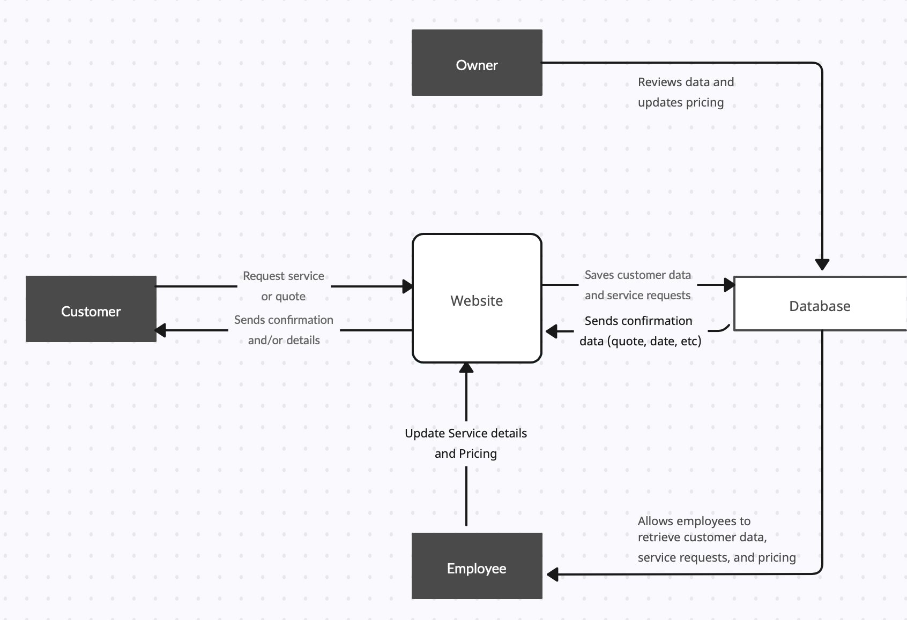

Use Case Diagram
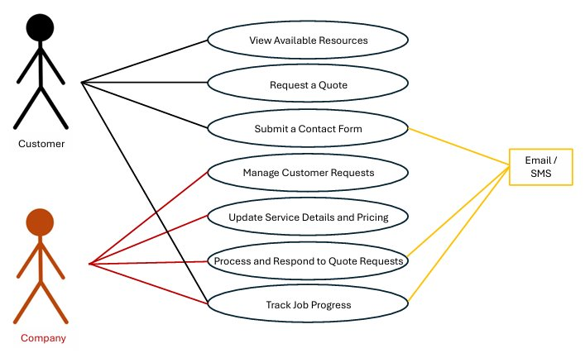

Sprint 2
In Sprint 2, we refined our scope and documentation based on feedback from Sprint 1. We updated our Use Case Diagram and Context Diagram to align with our refined requirements. Additionally, we defined key non-functional requirements, including operational, performance, security, and usability aspects. Development has commenced, with early progress reflected in our updated PSPI, including system screenshots. Finally, we revised our Product Backlog, Sprint 2 Backlog, and established our Sprint 2 Burndown Chart to track progress effectively.

Non-Functional Requirements
Operational
•Must be accessible via standard web browsers (Chrome, Firefox, Edge, Safari)
•Must be available at least 99% of the time excluding scheduled maintenance
•Must be able to handle at least 100 users without a degradation in performance
•All customers and administrator interactions with the site need to be logged for auditing purposes
Performance
•Page load times need not be excessive, ideally within or below 3 seconds load time
•The database must also be able to respond to queries within 3 seconds
•Batch processing should be able to complete within 30 seconds
•The system needs to be scalable, ideally able to handle a 30% increase in traffic annually
Security
•User authentication must be encrypted
•All sensitive data such as customer information should be encrypted as well
•The system needs preventative measures for SQL injection or other similar attack practices
•Users should be logged out after 15 minutes of inactivity
•Role based access should restrict access depending on your roles

Usability
•The UI should be simple and easy to use for customers and for employees
•Service requests should be completed within 3-5 clicks
•Admins should be able to update services and access customer data easily
•Actions should have clear error messages if unable to process requests

Sprint 3

Executive Summary
In Sprint 3, we focused on the design phase of our system, incorporating feedback from Sprint 2 to refine our approach. We updated our Context Diagram and created a Level 1 Data Flow Diagram (DFD) along with an IPO chart to enhance our process and data modeling. Additionally, we designed key user interface elements, including an Admin Panel, a dropdown bar, and an empty field pop-up for improved usability. We also initiated database development by creating essential database tables. To track our progress, we showcased our updated Product Backlog and the latest PSPI, incorporating quality-of-life changes to enhance functionality and user experience.

Entity Relationship Diagram
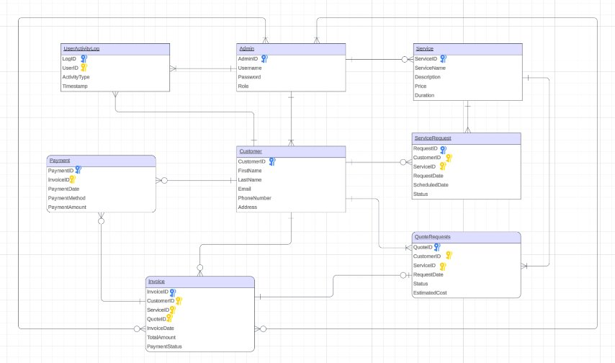

DFD Level 0
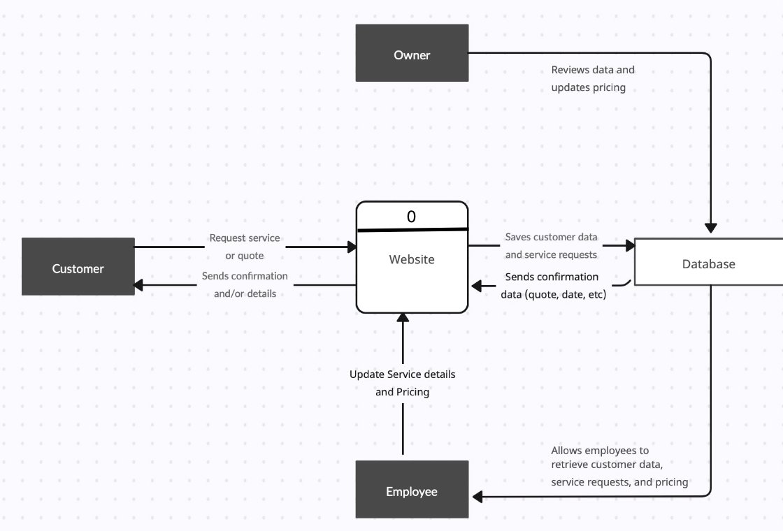

DFD Level 1

Hardware and Software Requirements
Hardware:
- Processor: Intel Core i5 or AMD Ryzen 5
- RAM: 8 GB
- Storage: 256 GB SSD
- Display: 1080p resolution
- Internet: Broadband connection (minimum 25 Mbps)
Software:
- Python 3.10+ (for backend operations)
- SQLite or PostgreSQL (for database)
- Web hosting panel (e.g., cPanel, Hostinger Control Panel)
- Text editor (e.g., VS Code, Sublime Text) for maintenance

Program Plan
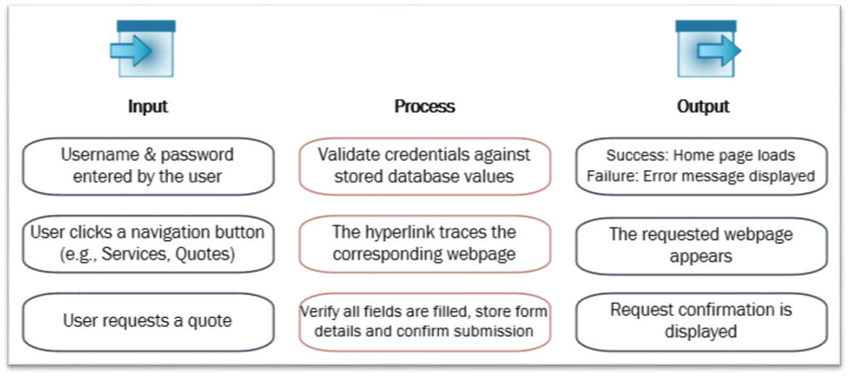

Sprint 4

Executive Summary
In Sprint 4, our team focused on refining the system based on feedback from Sprint 3. We updated our documentation, backlogs, and PSPI, and successfully developed and delivered a training session tailored to a key system actor. Technical and training manuals were created to support ongoing system use and maintenance. Overall, the team stayed on schedule and completed all required deliverables in preparation for the final handoff.

This section includes a training documents meant for any authorized admins of SLW Home Improvements. This training document will cover everything for logging in and logging out to how to manage customer quotes. Since there was no system in place prior to the creation of this one, we tried to make this as simple as possible. It is important to not have an overwhelming amount of features and tasks, which would make the transition difficult for all users.

Training Manual Training Manual

Customer Interactions with the Site
Upon loading the site, the customer will be directed to the home page showcased below. The initial screen allows them to navigate to four key areas of the site, “Services”, “Quotes”, “About us”, and “Contact”. The “Admin Login” section is for an administrator/manager and will be discussed later in the manual.
Figure 1.1

Services
Figure 1.2
If you click “Services”, you will be directed to a page where you can scroll through some of the different services offered by SLW Home Improvements, which is important on a couple points.
Firstly, it lets visitors to the website know specifically what the company has to offer and acts as a free way to advertise our services.
Secondly, it gives direction as to which service customers should choose when they request a quote.

Request Quote
Figure 1.3
If you select “Request Quote”, you will be directed to the quote request form.
Each field is listed below for further clarity
Field Name | Description | Input Type
Name | The name field is for the customer to input their name. | Text
Email | The email field is for the customer to input their email, which will be saved for future use on our system. | Text
Phone | The phone number is for the customer’s phone number and is used as for the manager/scheduler for SLW to contact the customer directly. | Number
Service | The service field is a drop down that allows the customer to select which service they are interested in receiving a quote for. | Dropdown
Notes | The notes field is for any additional notes or concerns the customer would like to include. | Text

About us
Figure 1.4
The about us page is a very simple pop-up and there is little interaction for the customer, this is more to give the customer a background on the company.

Contact Us
Figure 1.5
The contact us page, also available from the home page, is for the customer to reach out to the company with any questions that they may have or any message in general they would like to leave us. It contains 3 fields listed below.
Field Name | Description | Input Type
Name | The name field is for the customer to input their name so we know who is reaching out to us. | Text
Email | The email field is for the customer to enter their email, used as a point of contact for responding to their message. | Text
Message | The message field is for the customer to use to either ask questions or send us whatever message they would like. | Text

Admin Login
Figure 2.1
The admin login button is for the manager of SLW home improvements, and we will go through what the actor will need to know and how their interactions with the site will function.
Upon selecting “Admin Login”, the manager will be directed to the pop-up below.
Figure 2.2
From here, the admin/manager will input their username and password. In the event that they forget their name or password, they can select the “Forgot password?” button.
Figure 2.3
The admin will then enter their email associated with their login, and hit submit.
Figure 2.4
After hitting submit, they will receive a confirmation popup confirming that a link has been sent to their email to reset their password.

Admin Panel
Figure 2.5
This is the admin panel, which serves multiple functions but is used primarily to display the customer quotes and add services if needed.

Manage Services
Figure 3.1
The manage services sections allows the admin to add services, and upon entering the information and selecting “Add Service” will show either of the two popups below.
Figure 3.2
This popup indicates that the service was successfully added to the drop down
Figure 3.3
This popup indicates a failure, and the service will either need to be resubmitted or the manager will need to reach out to the system owner/manager.

Customer Quotes
Figure 4.1
Next, we have the customer quotes section. Here we have the customer information displayed next to the delete button, and the edit button.

Edit Customer Quotes
Figure 4.2
Upon selecting the “Edit” button, the manager can edit the details for customer quotes.
Figure 4.3
From here, they are brought to the same screen as before when requesting a quote, except the information will be filled out already and can be altered by the manager.
The main action item here is the “Status” section, which will need to be changed as the status changes for the quote/job.

Figure 4.4
Once the manager is done making their changes, they will need to select the “Update Quote” button for the changes to take effect.
Figure 4.5
Once they select “Update Quote”, they will be brought back to the Admin Panel.

Logging Out
Figure 4.6
For security reasons, it’s recommended that the manager/administrator log out whenever they are done accessing the admin panel. Upon selecting the logout button, they will be shown a confirmation screen and given the chance to go back to the home page.
Figure 4.7
Once they see this message, they will know that they are logged out.

SLW Home Improvements Technical Manual

System Overview
This system was developed to streamline SLW Home Improvements’ ability to manage service requests, quotes, customer information, and invoicing. It is a secure, browser-accessible platform requiring minimal hardware and software to operate. This was done in an effort to make the transition as seamless as possible.

Restart and Troubleshooting
The system is designed to be both lightweight and reliable. If the system becomes unresponsive or any error occurs:
- Close the current browser window.
- Reopen your browser and navigate back to the system.
- Log in again and continue from there.
In most cases, this will resolve common issues that occur. If your problems persist, contact your IT representative.

System Requirements
Hardware:
- Processor: Intel Core i5 or AMD Ryzen 5
- RAM: 8 GB
- Storage: 256 GB SSD
- Display: 1080p resolution
- Internet: Broadband connection (minimum 25 Mbps)
Software:
- Python 3.10+ (for backend operations)
- SQLite or PostgreSQL (for database)
- Web hosting panel (e.g., cPanel, Hostinger Control Panel)
- Text editor (e.g., VS Code, Sublime Text) for maintenance

Admin Login
Admins can access the system via the dedicated Admin Login page.
- Open your browser and go to the systems home page.
- Click “Admin Login”
- Enter your username and password given by the company.
- Click “Login”

If you forget your password, click “Forgot Password” and follow the prompts to reset it via your company email address.

Backing Up Data
Even though the database is hosted online, weekly backups are recommended. Contact your IT support team to:
- Schedule automated backups if possible
- Export a copy of the database
- Save it to an external location

Software Maintenance
System updates will be delivered from the dev team. These updates may include bug fixes, performance enhancements, or entirely new features.
BEFORE ANY SYSTEM UPDATE:
- Backup the existing database.
- Notify staff that updates are underway.
- Confirm system is working post update.

Database Recovery
In the unlikely event of a system failure resulting in data loss:
- Retrieve the most recent backup
- Replace the existing database file with the backup
- Restart the system and examine data

Current Limitations
- The system currently only supports web access
- There is no support for iOS or Android apps at this moment

Sprint 5 Corrections

Updated Hardware and Software Requirements

Software Requirements
Operating Systems:
- Windows 10 or later
- macOS 12 (Monterey) or later
- Ubuntu 22.04 LTS or later
Web Browsers:
- Google Chrome (latest stable version)
- Mozilla Firefox
- Microsoft Edge
- Safari (for macOS)
Note: Legacy browsers like Internet Explorer or Netscape Navigator are not supported.
Additional Software:
- Python 3.10+ (for backend operations)
- MySQL (for database)
- Web hosting panel (e.g., cPanel, Hostinger Control Panel)
- Text editor (e.g., VS Code, Sublime Text) for maintenance

Sprint 5
In Sprint 5, our focus shifted to ensuring a smooth transition from SLW Home Improvements’ manual processes to the newly developed digital system. We created a comprehensive migration plan addressing business, technical, and people readiness to prepare the organization for full system adoption. From a business readiness perspective, we aligned stakeholders with project goals, cleaned existing customer data, and established communication strategies for a seamless rollout. Technical readiness involved deploying the system in a secure environment, validating functionality through testing, and preparing full data backups. Finally, people readiness focused on equipping staff with training manuals, hands-on practice, and support resources to build confidence and ensure effective use of the system. This structured approach ensures a reliable, user-friendly transition to SLW’s new digital infrastructure.

Migration Plan

Business Readiness
To ensure business readiness, our team has reviewed and cleaned all existing customer records, service requests, and quote data currently maintained in spreadsheets and paper files. These records are being formatted for import into the new database. We have mapped current workflows to their digital equivalents in the new system and identified necessary adjustments to streamline daily operations.
We have also developed a communication schedule to keep SLW Home Improvements’ staff informed throughout the rollout. This includes scheduled update emails, a project timeline with key transition dates, and a pre-launch walkthrough session to review new processes and expectations. All materials will be delivered in advance to ensure staff are aligned and prepared.

Technical Readiness
The system is being deployed in a secure cloud-hosted environment with SSL encryption and role-based access control. The SQLite database has been installed and configured, and admin login credentials have been created for the management team.

We have completed internal testing to confirm system functionality, including quote submissions, login/logout processes, and admin panel operations. A full backup of the system has been created and stored securely. Historical data migration is currently underway using a mix of automated scripts and manual input for legacy records. Upon deployment, all components will be re-tested to confirm readiness for launch.

People Readiness
To prepare SLW staff for using the new system, we have developed a user-friendly training manual and delivered a hands-on training session covering all major tasks: logging in, creating and updating quotes, adding services, and managing customer data.
Each staff member has been provided access to a test version of the site to practice using real workflows. A designated point of contact from our team is available for post-launch support via phone and email. A phased rollout is planned, beginning with admin access and then extending to public access, allowing time to resolve any user issues and ensure a smooth transition.
Sprint 6

Lessons Learned
Throughout this project, we encountered challenges that provided valuable insights. These experiences enhanced our understanding as well as sharpened our approach to future projects or endeavors. By reflecting on the lessons we learned during this project, we can apply this newfound knowledge to optimize processes and build stronger relationships for success moving forward. Below are the most significant takeaways:
- We learned the importance of gathering clear and detailed requirements
- Agile sprints allow us to adapt quickly to feedback and changes
- Prioritizing security early made integration smoother
- Simple, user-friendly design is just as important as functionality
- Thorough testing helped prevent deployment issues
- Well-written documentation ensures long-term system usability

Challenges, Problems, and Discoveries
This system's creation did come with some major challenges; some we were able to work around easily while others took more time and effort. Below are the major challenges that we faced during this system creation:
- No existing digital system – operations were pen-and-paper based
- Required complete system build, website, database, and admin tools
- Limited technical experience among end-users
- Balancing ease of use with functional requirements
While the challenges were a pain to work around, the problems that we faced were even more of an issue. These problems could have been detrimental to the team, the project, and the company if not handled correctly. Listed below are the main problems that we encountered:
- Difficulty gathering requirements without prior systems to reference
- Inconsistent or incomplete data in manual records
- Risk of overwhelming users with complex features
- Limited timeline to develop, test, and deploy a full solution
Lastly there are the discoveries, the things that we as a group and as individuals will take with us as this project concludes. We will bring these discoveries with us to refer back to in future endeavors:
- Simpler interfaces are more effective for non-technical users
- Frequent demos and feedback loops improved design decisions
- Starting from scratch allowed full customization without legacy constraints
- Thorough user training and documentation is key for adoption

Appendix
All burndown charts, meeting logs, and product backlogs are attached to this document as excel spreadsheets.

